Page URL: **/content/en/us/products/ios-nx-os-software/index**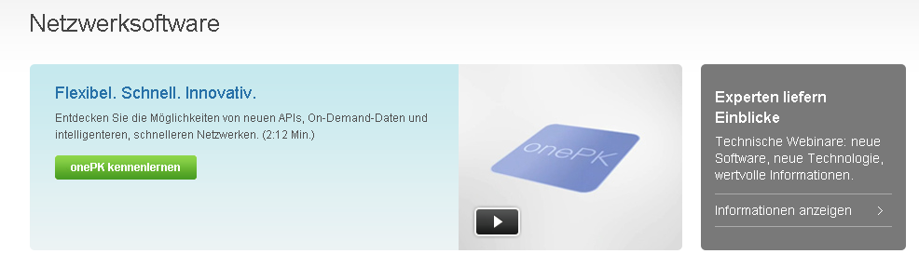

5/content/en/us/products/ios-nx-os-software/index/jcr:content/content_parsys/overview_alt1/layout-overview-alt1/gd12v2/gd12v2-left/text

4

2

3

1

6

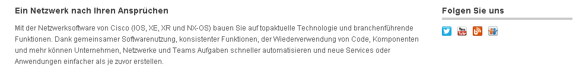

9/content/en/us/products/ios-nx-os-software/index/jcr:content/content_parsys/overview_alt1/layout-overview-alt1/gd12v2/gd12v2-left/text

8/content/en/us/products/ios-nx-os-software/index/jcr:content/content_parsys/overview_alt1/layout-overview-alt1/gd12v2/gd12v2-left/text

7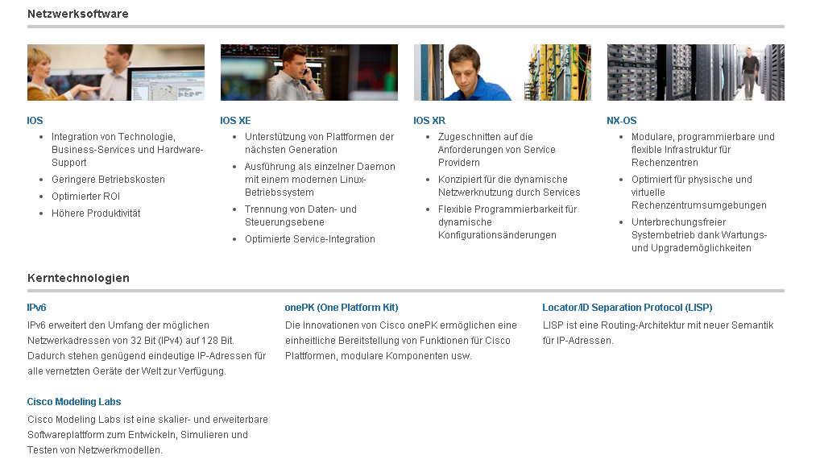



10000

171000

181000

161000

151000

121000

131000

141000

111000

|  |  |  |
| --- | --- | --- |
| 1 | /content/<locale>/products/ios-nx-os-software/index/jcr:content/content_parsys/overview_alt1/layout-overview-alt1/gd12v2/gd12v2-left/hero_large/heropanel*/title | Select(“div.gd-left”).select("div.c50-text").getElementsByTag("h2") |
| 2 | /content/<locale>/products/ios-nx-os-software/index/jcr:content/content_parsys/overview_alt1/layout-overview-alt1/gd12v2/gd12v2-left/hero_large/heropanel*/description | Select(“div.gd-left”).select("div.c50-text").getElementsByTag("p") |
| 3 | /content/<locale>/products/ios-nx-os-software/index/jcr:content/content_parsys/overview_alt1/layout-overview-alt1/gd12v2/gd12v2-left/hero_large/heropanel*/linktext  /content/<locale>/products/ios-nx-os-software/index/jcr:content/content_parsys/overview_alt1/layout-overview-alt1/gd12v2/gd12v2-left/hero_large/heropanel*/linkurl | Select(“div.gd-left”).select("div.c50-text").getElementByTag(“p”).getElementsByTag("a").attr(“href”)  Select(“div.gd-left”).select("div.c50-text").getElementByTag(“p”).getElementsByTag("b") |
| 4 | /content/<locale>/products/ios-nx-os-software/index/jcr:content/content_parsys/overview_alt1/layout-overview-alt1/gd12v2/gd12v2-right/primary_cta_v2/title | Select(“div.gd-right”).select("div. c47-pilot").getElementsByTag("h3") |
| 5 | /content/<locale>/products/ios-nx-os-software/index/jcr:content/content_parsys/overview_alt1/layout-overview-alt1/gd12v2/gd12v2-right/primary_cta_v2/description | Select(“div.gd-right”).select("div. c47-pilot").getElementsByTag("p") |
| 6 | /content/<locale>/products/ios-nx-os-software/index/jcr:content/content_parsys/overview_alt1/layout-overview-alt1/gd12v2/gd12v2-right/primary_cta_v2/linktext  /content/<locale> /products/ios-nx-os-software/index/jcr:content/content_parsys/overview_alt1/layout-overview-alt1/gd12v2/gd12v2-right/primary_cta_v2/linkurl/url | Select(“div.gd-right”).select("div. c47-pilot").getElementsByTag("a")  Select(“div.gd-right”).select("div. c47-pilot").getElementsByTag("a").attr(“href”) |
| 7 | /content/<locale>/products/ios-nx-os-software/index/jcr:content/content_parsys/overview_alt1/layout-overview-alt1/gd12v2/gd12v2-left/text/text | Select(“div.text parbase section”).Select(“div.c100-pilot”) |
| 8 | /content/<locale>/products/ios-nx-os-software/index/jcr:content/content_parsys/overview_alt1/layout-overview-alt1/gd12v2/gd12v2-right/followus/title | Select(“div.gd-right”).select("div. s14-pilot").getElementsByTag("h2") |
| 9 | /content/<locale>/products/ios-nx-os-software/index/jcr:content/content_parsys/overview_alt1/layout-overview-alt1/gd12v2/gd12v2-right/followus/links | Select(“div.gd-right”).select("div. s14-pilot").getElementsByTag("a").attr(“href”) |
| 10 | /content/<locale>/products/ios-nx-os-software/index/jcr:content/content_parsys/overview_alt1/layout-overview-alt1/gd11v1_0/gd11v1-mid/text/text | Select(“div.text parbase section”).Select(“div.c100-pilot”) |
| 11 | /content/<locale>/products/ios-nx-os-software/index/jcr:content/content_parsys/overview_alt1/layout-overview-alt1/gd14v1/gd14v1-left/text/text | Select(“div.text parbase section”).Select(“div.c100-pilot”) |
| 12 | /content/<locale>/products/ios-nx-os-software/index/jcr:content/content_parsys/overview_alt1/layout-overview-alt1/gd14v1/gd14v1-mid-left/text/text | Select(“div.text parbase section”).Select(“div.c100-pilot”) |
| 13 | /content/<locale>/products/ios-nx-os-software/index/jcr:content/content_parsys/overview_alt1/layout-overview-alt1/gd14v1/gd14v1-mid-right/text/text | Select(“div.text parbase section”).Select(“div.c100-pilot”) |
| 14 | /content/<locale>/products/ios-nx-os-software/index/jcr:content/content_parsys/overview_alt1/layout-overview-alt1/gd14v1/gd14v1-right/text/text | Select(“div.text parbase section”).Select(“div.c100-pilot”) |
| 15 | /content/<locale>/products/ios-nx-os-software/index/jcr:content/content_parsys/overview_alt1/layout-overview-alt1/gd11v1/gd11v1-mid/text/text | Select(“div.text parbase section”).Select(“div.c100-pilot”) |
| 16 | /content/<locale>/products/ios-nx-os-software/index/jcr:content/content_parsys/overview_alt1/layout-overview-alt1/gd13v2/gd13v2-left/text*/text | Select(“div.text parbase section”).Select(“div.c100-pilot”) |
| 17 | /content/<locale>/products/ios-nx-os-software/index/jcr:content/content_parsys/overview_alt1/layout-overview-alt1/gd13v2/gd13v2-mid/text/text | Select(“div.text parbase section”).Select(“div.c100-pilot”) |
| 18 | /content/<locale>/products/ios-nx-os-software/index/jcr:content/content_parsys/overview_alt1/layout-overview-alt1/gd13v2/gd13v2-right/text/text | Select(“div.text parbase section”).Select(“div.c100-pilot”) |
|  |  |  |
|  |  |  |